**WEEK-5**

Q1. #include<stdio.h>

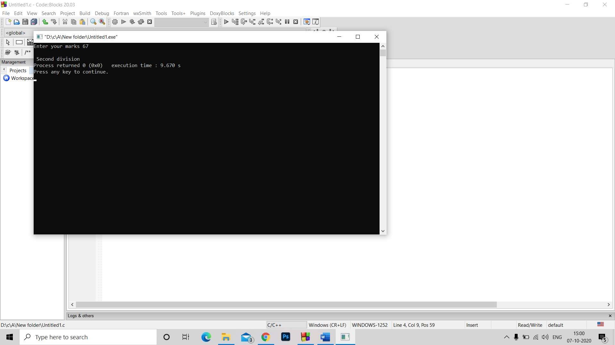#include<stdlib.h>

int main()

{ int a;

printf("Enter your marks ");

scanf("%d",&a);

if(a<=100 && a>=0)

{

if(a>=75)

printf("\n First division");

else if(a>=65)

printf("\n Second division");

else if(a>=55)

printf("\n Third division");

else if(a<55)

printf("\n Fourth division");

}

else printf("\n Invalid input");

}

Q2. #include<stdio.h>

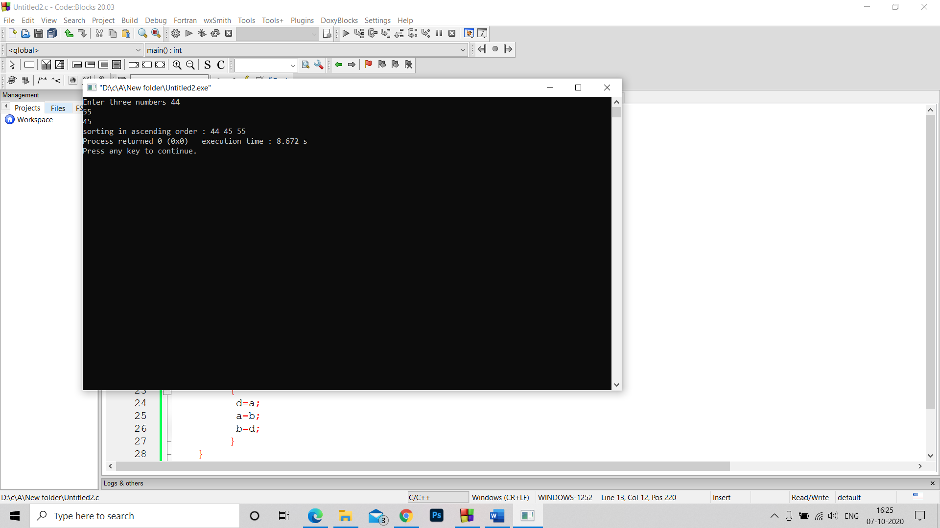#include<stdlib.h>

int main()

{ int a,b,c,d;

printf("Enter three numbers ");

scanf("%d%d%d",&a,&b,&c);

printf("sorting in ascending order : ");

if (b<a)

{

d=a;

a=b;

b=d;

}

if (c<b)

{

d=c;

c=b;

b=d;

if (b<a)

{

d=a;

a=b;

b=d;

}

}

printf("%d %d %d",a,b,c);

}

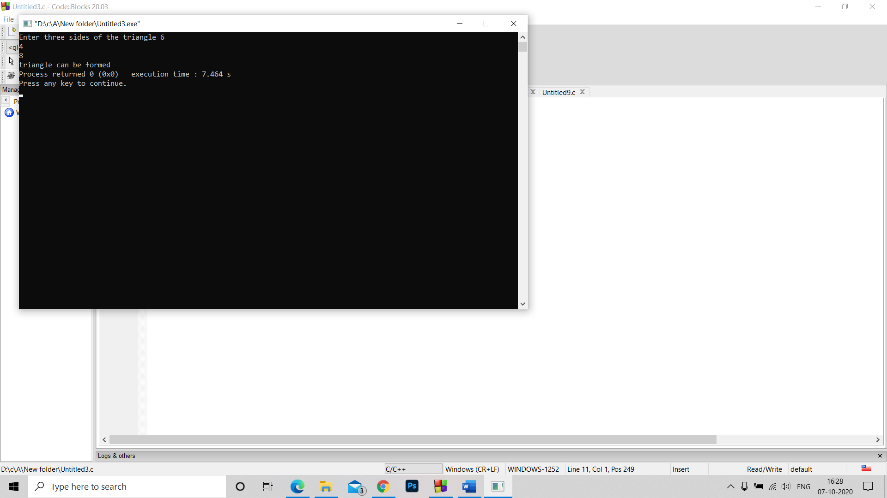Q3. #include<stdio.h>

#include<stdlib.h>

int main()

{ int a,b,c;

printf("Enter three sides of the triangle ");

scanf("%d%d%d",&a,&b,&c);

if(a+b>c && a+c>b && b+c>a)

printf("triangle can be formed");

else printf("triangle cannot be formed");

}

Q4. #include<stdio.h>

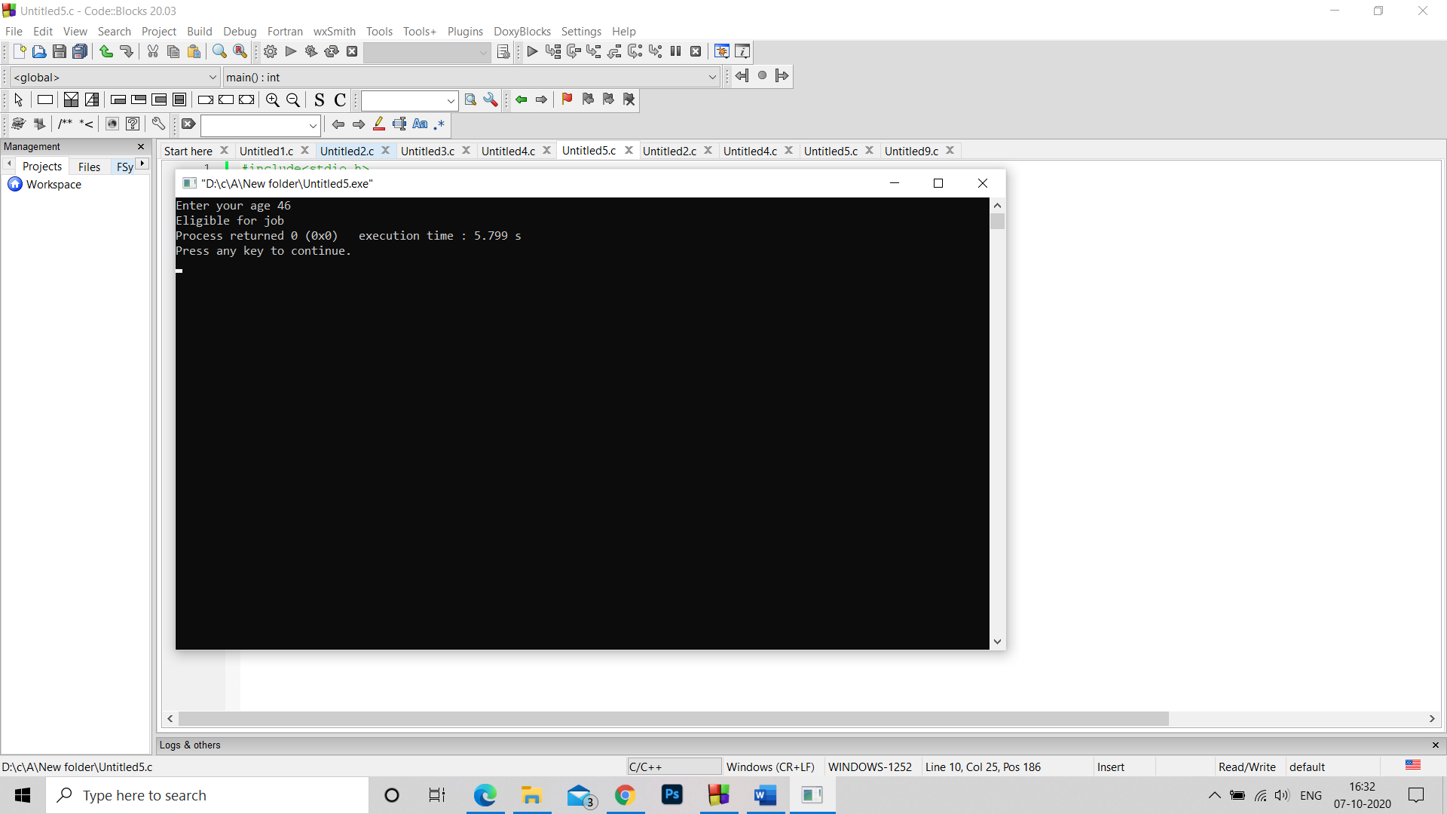#include<stdlib.h>

int main()

{ int a;

printf("Enter your age ");

scanf("%d",&a);

if(a>=18)

{if(a<=50)

printf("Eligible for job");

else printf("Not Eligible for job");

}

else printf("Not Eligible for job");

}

Q5. #include<stdio.h>

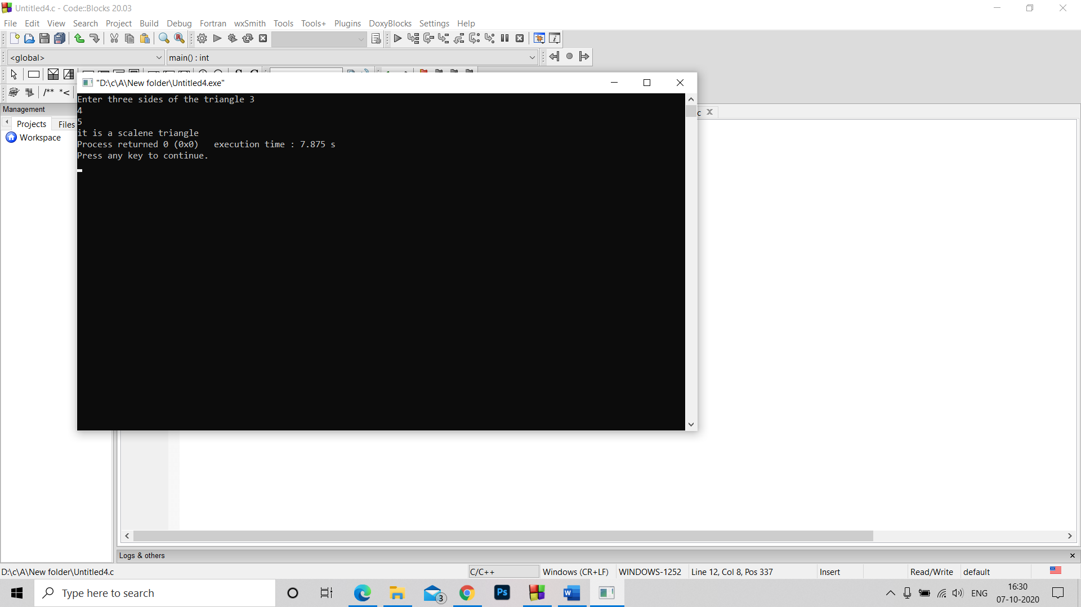#include<stdlib.h>

int main()

{ int a,b,c;

printf("Enter three sides of the triangle ");

scanf("%d%d%d",&a,&b,&c);

if(a+b>c && a+c>b && b+c>a)

{ if(a==b==c)

printf("it is an equilateral triangle ");

else if(a==b && b!=c || a==c && c!=b || b==c && c!=a)

printf("it is a isoceles triangle ");

else

printf("it is a scalene triangle ");

}

else printf("triangle cannot be formed");

}